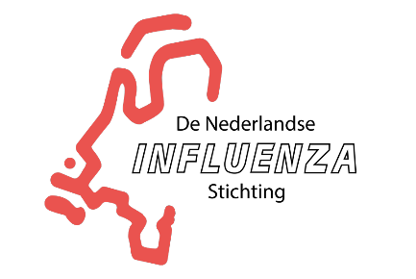 www.influenzastichting.nl
Secretariat: Paladijnenweg 30, 3813 DJ Amersfoort

Year report 2019

The NIS aims to contribute to the prevention and reduction of influenza-associated disease. It advocates implementation of evidence-based national recommendations for immunization with the flu shot by engaging stakeholders, risk groups, researchers and through (social) media communication.

Introduction
In the late nineties, the NIS (Dutch Influenza Foundation) abrogated itself after contributing to the successful increase of the Dutch flu vaccination coverage rate. Perhaps a bit too soon – considering that vaccination coverage rates started dropping in the late zeros. In May 2018, the Dutch senior citizen association (KBO-PCOB) rang the alarm bells. They noticed an increasing flu disease burden amongst their members. KBO-PCOB requested the government and society to make an Action Winter Mortality. And that’s why and when it was decided to re-establish the NIS. We received a starting budget from Holland Bio, to organise Statutes for the foundation and a website www.Influenzastichting.nl. Also, in 2018 the board was put together: Dr G.A. (Ted) van Essen (chair), Dr A.M. (Bram) Palache (secretary/treasurer), Dr W.E.P. (Walter) Beyer (board member and scientific advisor). In 2019, we started making plans and find sponsors. In 2019, the pharmaceutical firms Mylan, Sanofi, GSK and Seqirus were very kind to support the NIS with an unconditional grant.

Activities
We had two main activities:
- Starting a social media campaign, based on the existing Influenzahub. The Dutch version (www.beterzondergriep.nl with the Facebook page https://www.facebook.com/Beterzondergriep/ started in September 2019.
- To organise a Nationale Griepprikdag (National Flu Shot Day), where all relevant parties would join.

Results
- Social media
Even with the late start, the results of the Influenza hub were promising. The pilot outperformed expectations, also compared to other countries. There was a high number of engagements for the target audience 60+. This audience wants to dig deeper, resulting in a high number of click-trough’s and a long "time on screen". There were more than 277,9K
impressions and 5.2K conversation engagements (post reactions, comments & shares). On Facebook 53% of the conversation was positive, 39% negative and 8% neutral.
We did not focus on the Influenzastichting.nl channels. Still, we had 17.400 contacts from 15.468 different sources.

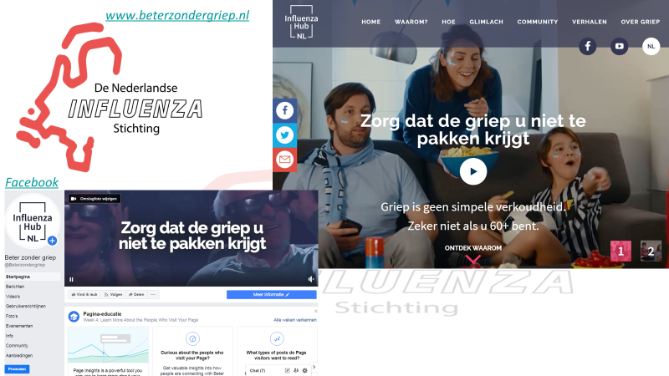

- The Nationale Griepprikdag took place inside the Ministry of Health (VWS) in The Hague on 11 November. Dep-MoH Paul Blokhuis opened the meeting. The focus of the meeting was on Influenza vaccination for Health Workers. The discussion was moderated by Jack van den Kieboom and the catering was also financed by the Ministry.
There were contributions of the Senior Organisation KBO-PCOB (Manon Vanderka), from the National Influenza Centre (Ron Fouchier), from the European Specialist Nurses Association (Ber Oomen), from the Federation of Medical Doctors KNMG (René Héman) and from the National Hospital Association NVZ and Nursing home/Homecare Organisation ActiZ (Arno Timmermans).
There were 65 participants, all from relevant parties. With the help of a PR-bureau we managed to get a lot of attention: on TV (7 different programs on national tv), on national radio (5 stations), in print (4 national newspapers, the magazine of the Medical Doctors Federation KNMG and of the senior organisation KBO-PCOB) and on line from more than 60 different news agencies). On twitter more than 120 tweets from different, relevant organisations were published.
A short evaluation form by e-mail one week later, was received from 10 participants. The average appreciation was 8 (on a scale of 1-10). Most reactions were positive. A special evaluation session was held with the Ministry of Health and the sponsors. All were positive about the meeting.

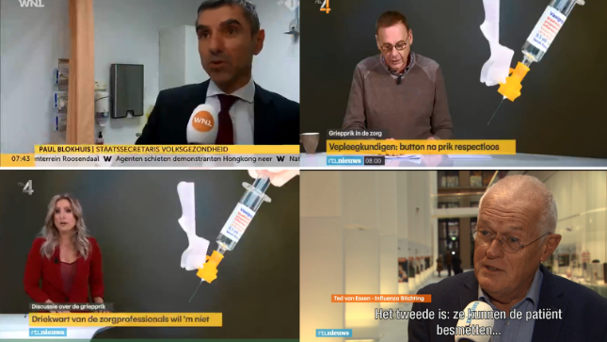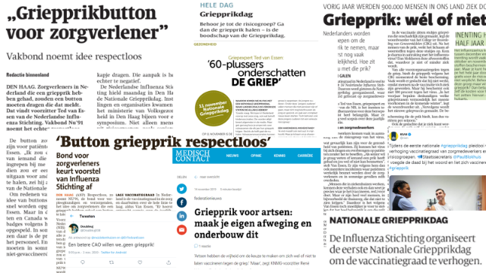

Finance
The budget for 2019 was based on the assumption that we could reclaim the VAT. Unfortunately, this was prohibited by the tax inspector. As a result, we did foresee a deficit of 21%. We had to economise, but happily the Ministry of Health offered to host the meeting, which was thankfully accepted. Next, we had to screw back out social media activities and office costs. The result was a small profit at the end of 2019, to enable us to continue the social media activities in the beginning of 2020, albeit on a minimum level. For 2020, we will try to receive the sponsoring earlier to avoid liquidity problems.

Plans for 2020
- Increase and improve social media activities: more original Dutch content with more personal stories and active promotion using Facebook adds.
- Yearly National Flu Shot Day: full day, looking back to the 2019 HCW’s focus and looking forward to the combination of flu- and pneumococcal vaccination for 60+, flu shots for pregnant women and children and the new vaccines in the pipeline.
- Increase demand through senior- and patient associations: in 2019 we collaborated with the senior organisation KBO-PCOB. In 2020 will extend our activities to patient organisations in the field of the flu risks (lung fund, heart association, diabetes fund, etc.).
- Stakeholder meeting: under the umbrella of the Vaccination Alliance of the Ministry of Health, we will organise a discussion between all stakeholders in the influenza vaccination campaign. From the demand side, the senior organisations and the patient organisations of at risk groups (KBO-PCOB, ANBO, Patiëntenfederatie Nederland, Longfonds, Hartstichting, Diabetesfonds, KWF, Reumafonds). From the providers, professional organisations (LHV, NHG, FMS, NVAB, KAMG, V&VN, Nu91, professional organisations of cardiologists, lung specialists, oncologists, rheumatologists). From the NPG (National Program Influenzavaccination), RIVM and SNPG. Goal is to analyse barriers and gaps in raising the vaccination rate back to the EU-target of 75%.
- Promote flu shots for health professionals with as spin-off more active advocacy to patients at risk. The low vaccination rate in HCP is an eyesore for us and many of the professional organisations. The dep-MoH is preparing a plan to improve the situation, with mandatory vaccination as a last resort opportunity. The NIS will actively participate in this process.
- Break down barriers in logistics: for risk patient the accessibility can be improved by offering new points of care (pharmacies?). For HCW’s the logistics can be improved by incorporating it into the national program for risk patients (NPG). Especially small health care sites (home care, small nursing homes), have problems organising vaccination hours. Following the British example, general practices and pharmacies could play an important role in improving the accessibility. The NIS will try to influence the process.
- Broadening the basis of the NIS by involving (young) scientists and public health people in an advisory board.

